PORTFOLIO

ASSIGNMENT OF CSE111 (ORIENTATION TO COMPUTING-1)

COMPUTER SCIENCE AND ENGINEERING

Submitted by:

Bhagyalakshmi K Babu

12409371

Roll No.:34

Section: K2FD

Submitted to:

Dr. Harjit Singh



**LOVELY PROFESSIONAL UNIVERSITY**

**DECLARATION**

I, Bhagyalakshmi K Babu, a student of Bachelor of Technology under CSE discipline at Lovely Professional University, Punjab, hereby declare that all the information furnished in this project report is based on my own work and is genuine

Registration Number: 12409371

|  |  |  |
| --- | --- | --- |
| Platforms for profile creation | Link to student profile | Screenshot |
| ***Figma*** |  | 1 |
| ***Quora and***  ***LinkedIn*** | <https://www.linkedin.com/in/bhagyalakshmi-k-babu/> | 2 |
| ***Stack overflow*** | <https://stackoverflow.com/users/28534029/bhagyalakshmi> | 3 |
| ***Hacker Rank*** |  | 4 |
| ***Hacker Earth*** | [https://www.hackerearth.com/@bhagyalakshmi-i/](%20%20%20%20%20%20%20%20https://www.hackerearth.com/@bhagyalakshmi-i/) | 5-6 |
| ***Geeks for Geeks*** | <https://www.geeksforgeeks.org/user/bhagyalakshmmnl4/> | 7 |
| ***Github*** | <https://github.com/Bhagyalakshmi-i> | 8 |
| ***Git*** |  | 9 |
| ***CV*** | <https://drive.google.com/file/d/1MCo4qnP9ZSya6EYs_hRkEAXELzjRPpIP/view?usp=share_link> | 10 |
| ***Technical mooc***  ***registration Link and screenshot*** | <https://drive.google.com/file/d/1eISFQsNNc3_J0tq4cmpkzmwBbpqyaQ5L/view?usp=share_link> | 11 |

# FIGMA

Profile:

Figma internal profile

# LINKEDIN

Profile: 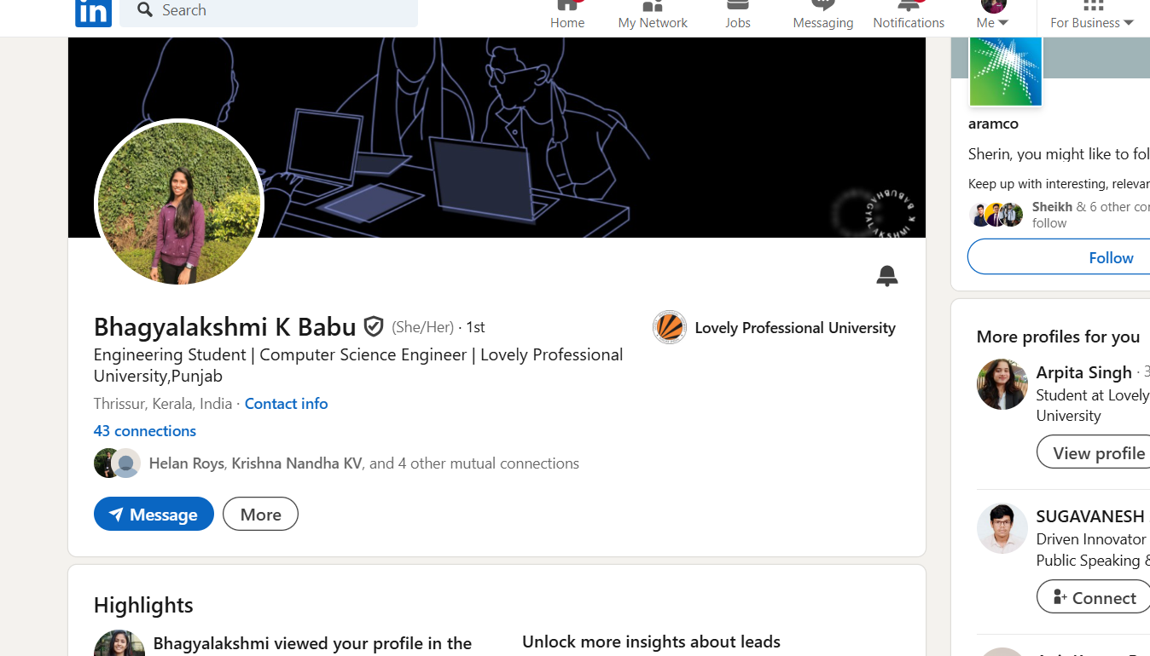

# STACKOVERFLOW

Profile:

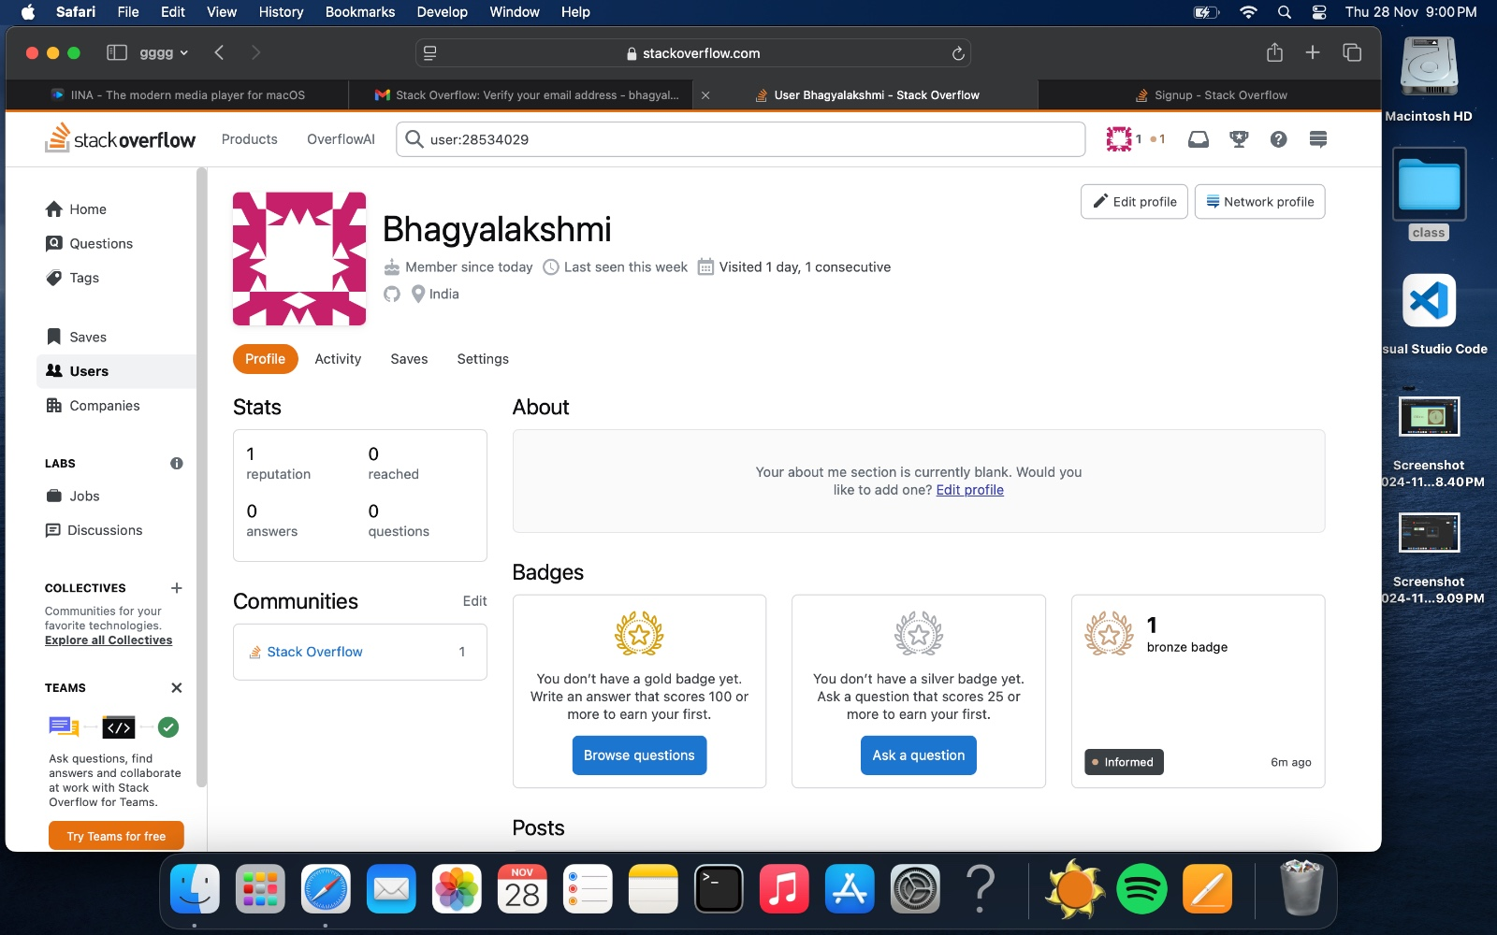

Accomplishment: completed the profile and got a badge



# HACKER RANK

Profile:

# HACKER EARTH

Profile:

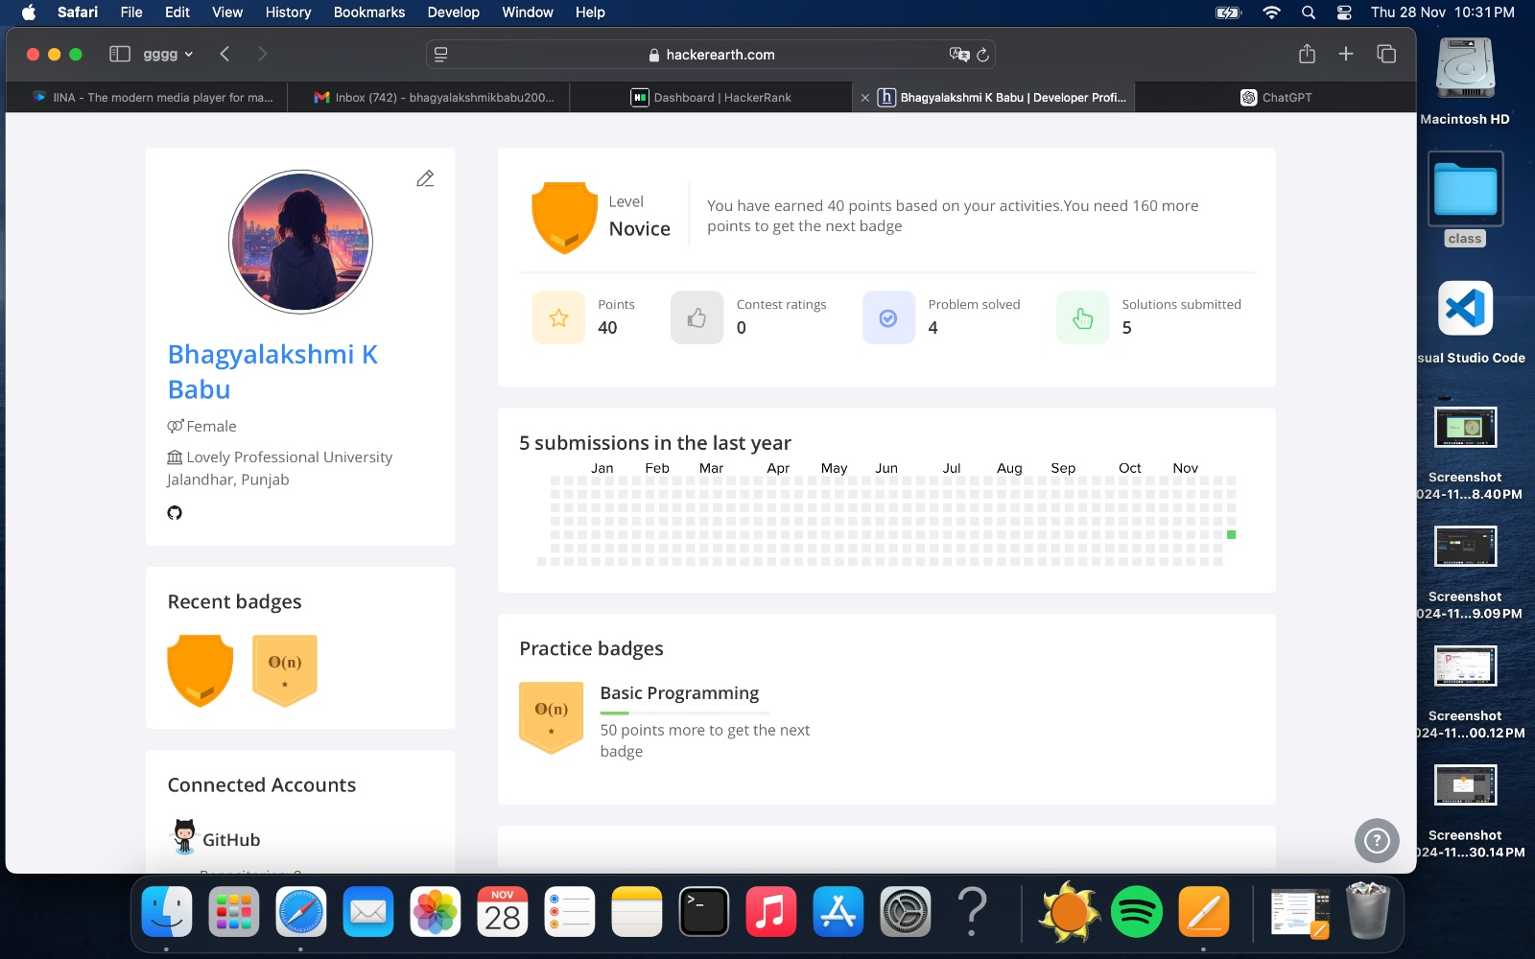

Accomplishment:

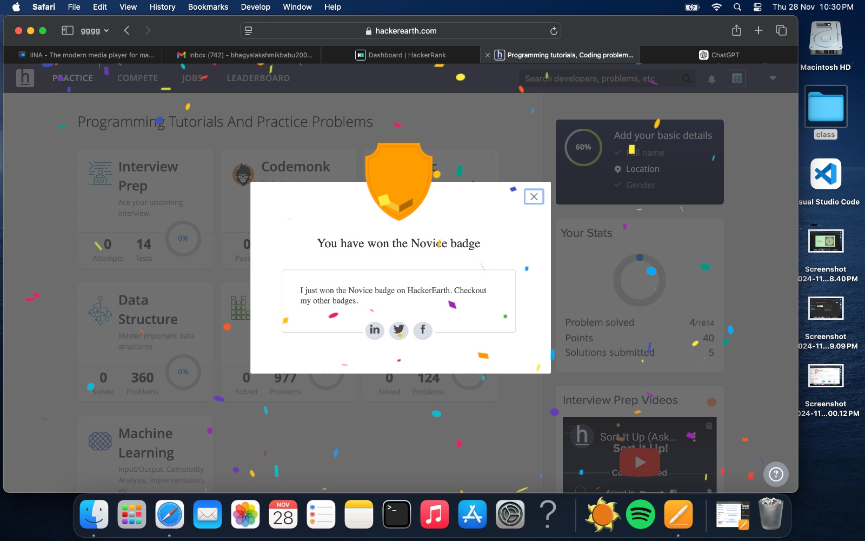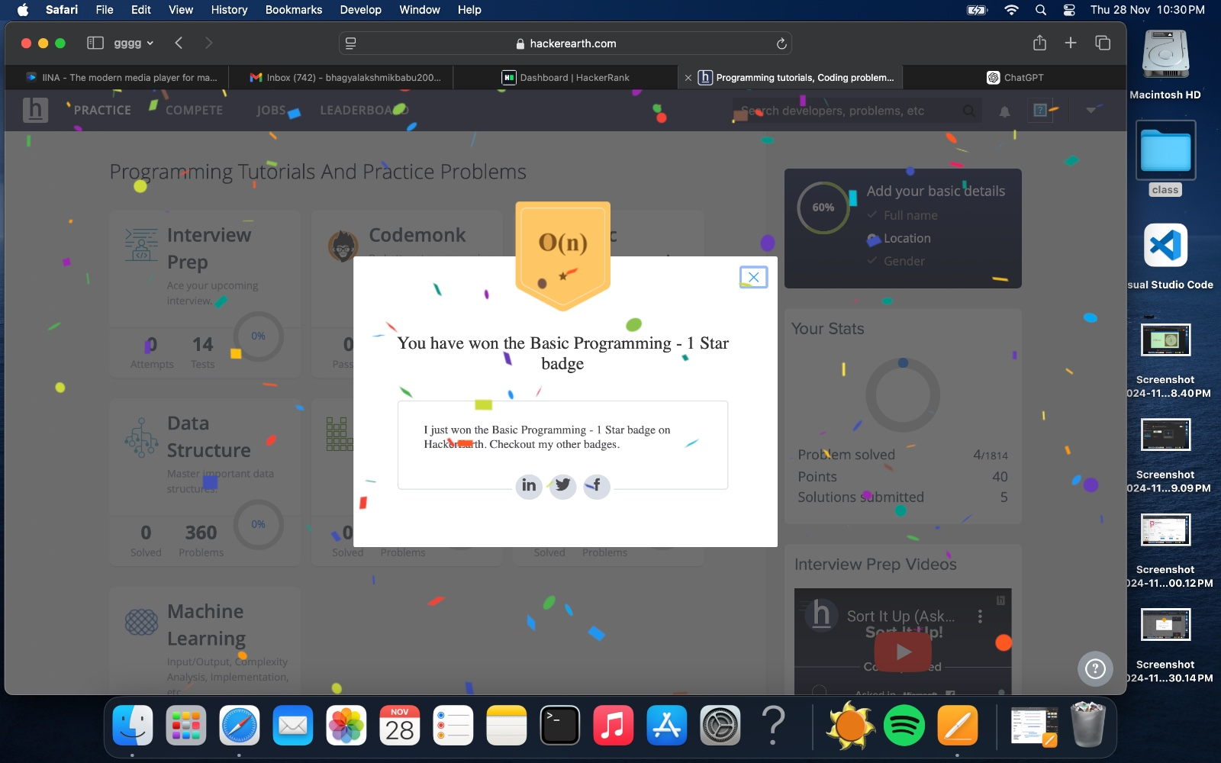

# GEEKS FOR GEEKS

Profile:

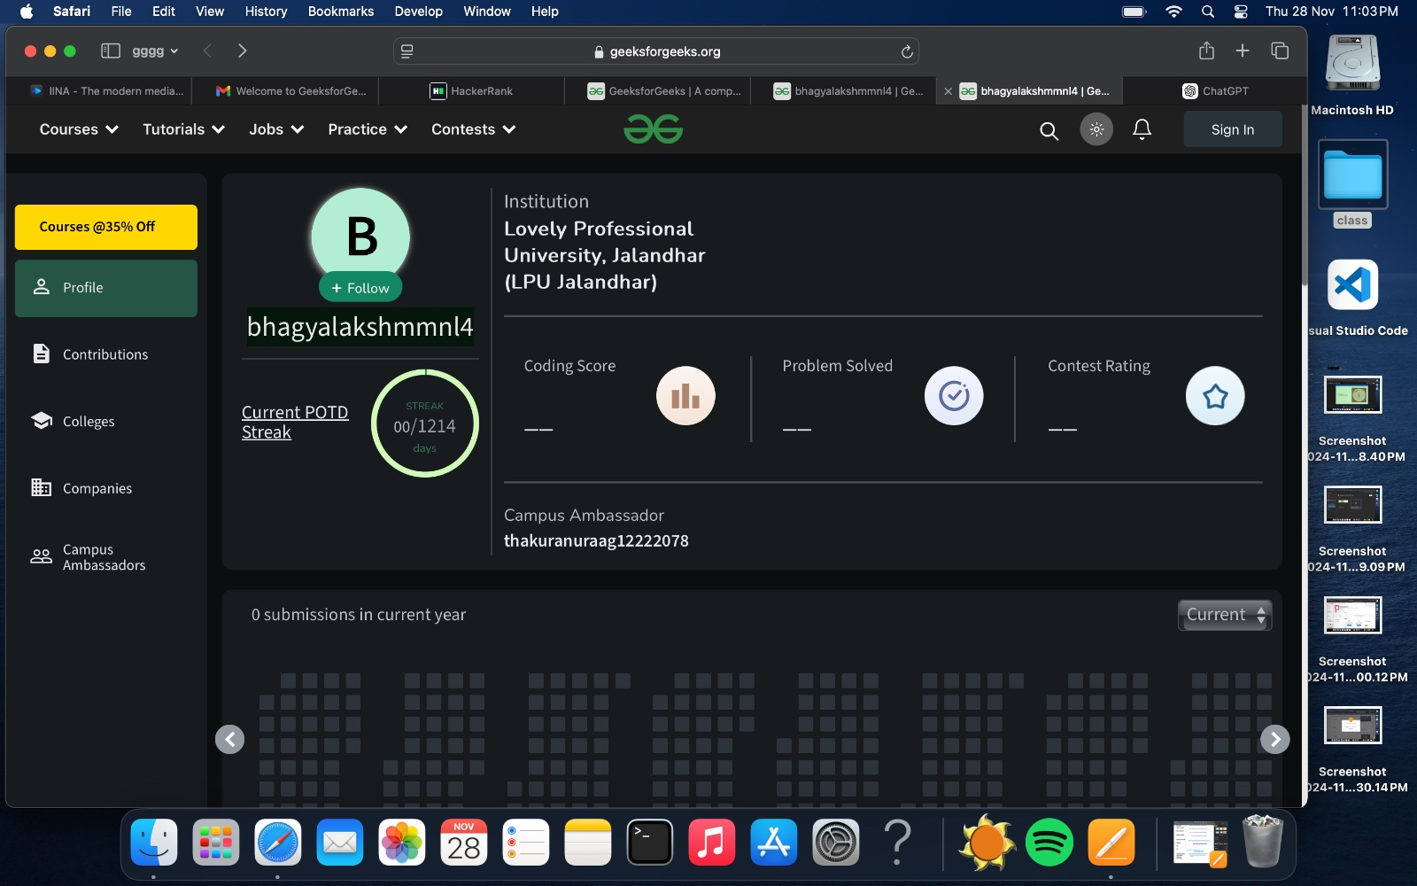

# GITHUB

Profile:

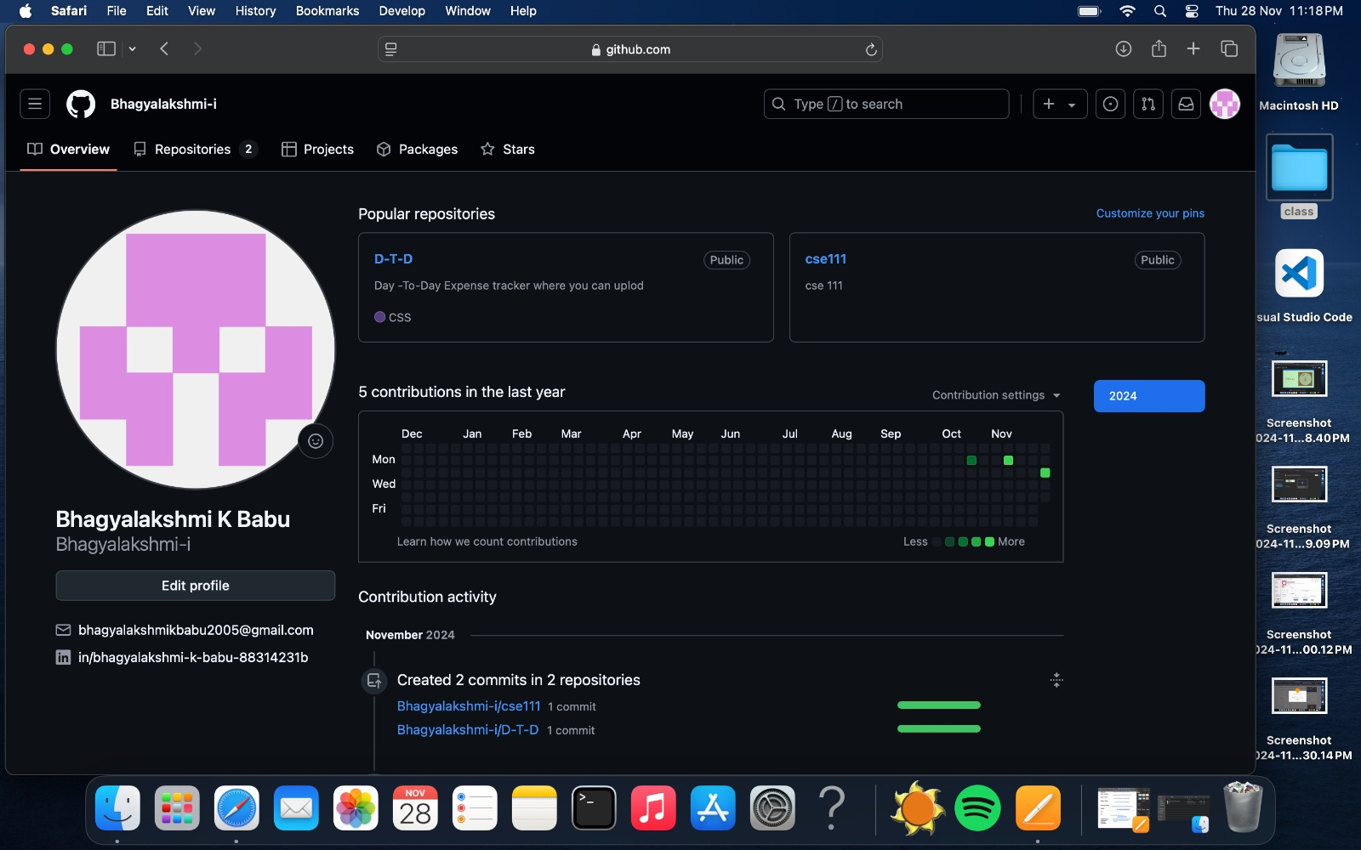

Added a repository:

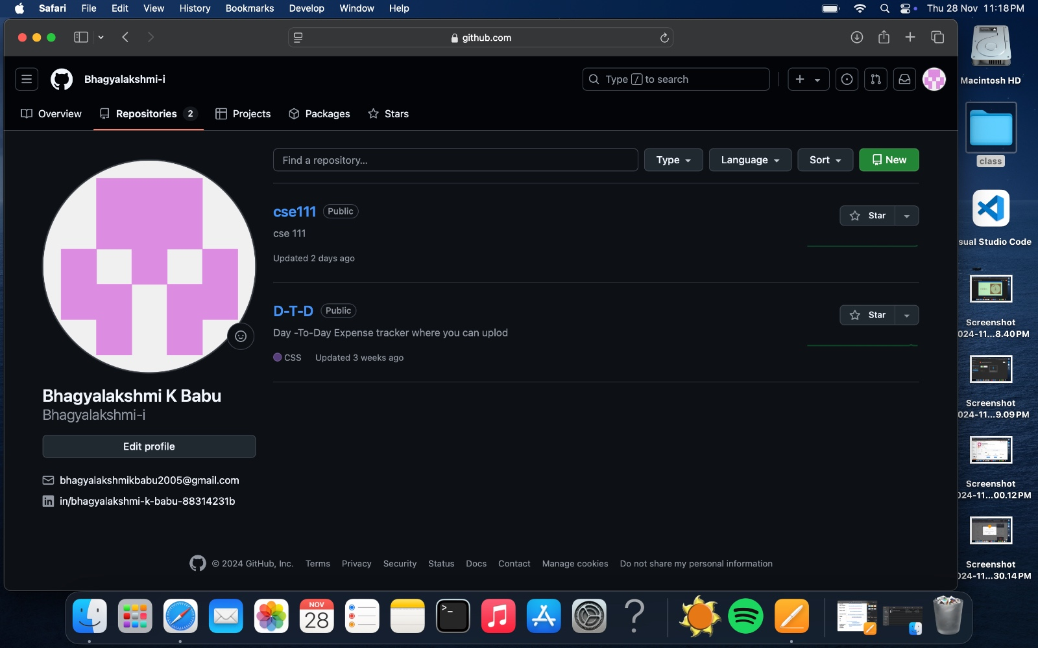

# 8.GIT

# 9.CV

# 

10.Technical MOOC registration link and screenshot

